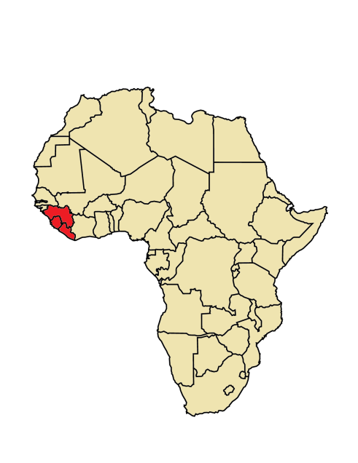

If you have been to **Sierra Leone, Guinea, or Liberia** in the past month, there is a possibility that you may have been exposed to **Ebola**

01/08/20154

**What is Ebola?** Ebola is the cause of a viral hemorrhagic fever disease. Symptoms include: fever, headache, joint and muscle aches, weakness, diarrhea, vomiting, stomach pain, lack of appetite and abnormal bleeding. Symptoms may appear anywhere from 2 to 21 days after exposure to Ebola virus, though 8-10 days is most common.

**How does Ebola spread?**You can only get Ebola from:

* Touching the blood or bodily fluids of a person who is sick with or has died from Ebola
* Touching contaminated objects, such as needles
* Touching infected primates or fruit bats

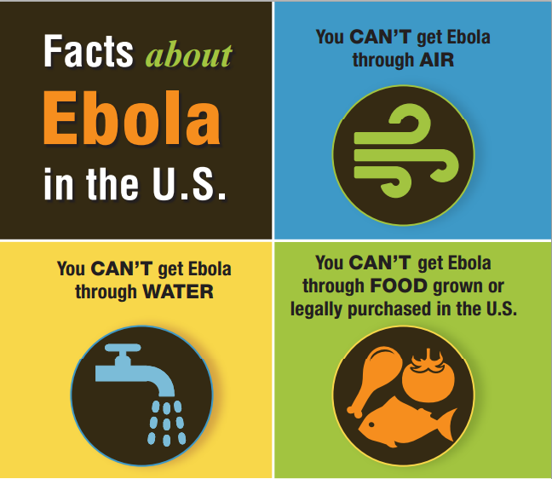

**Ebola is NOT spread through air, water, or food produced in the U.S.**

**For more information:**

[**www.ncdhhs.gov/ebola/**](http://www.ncdhhs.gov/ebola/)

*Enter your agency information/logos here*

­­­­­­**N.C. Ebola Public Information Line: 1-844-836-8714**

**North Carolina Public Health**

**NC Department**

**of Health and**

**Human Services**